**IN CLASS 2**

1. A plot of the logarithm of the diffusion coefficient versus reciprocal of absolute temperature is shown in the below figure, for the diffusion of copper in gold. Determine values for the activation energy (Qd) and the preexponential (Do).

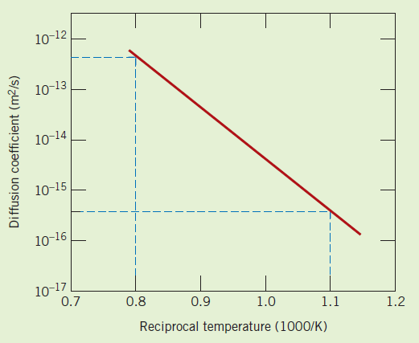

1. The diffusion coefficients for copper in aluminum at 500 and 600°C are 4.8×10-14 and 5.3×10-13 m2/s, respectively. Determine the approximate time at 500°C that will produce the same diffusion result (in terms of concentration of Cu at some specific point in Al) as a 10 h heat treatment at 600°C.